

**Database Systems**

**Lab No.9**

**Submitted By**

**Soha Ali**

**51169**

**Submitted To:**

**Ma’am Hafsah Mehmood**

**Solution:**

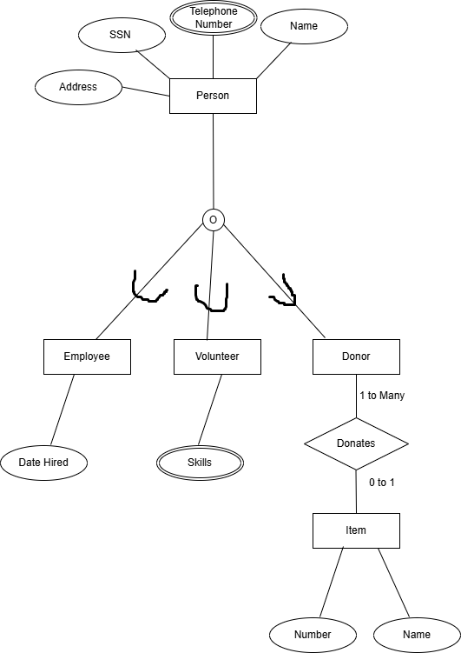

**Explanation:**

1. We have created an entity named Person with attributes Name, SSN, Address, and Telephone Number (a double oval is surrounding it because it is a multivalued attribute)
2. The entity Person has partial overlapping specialization with Employee, Volunteer and Donor. This indicates that a Person may be any one of them or neither.
3. The Employee and Volunteer entities have Date Hired and Skill (multivalued attribute) attributes respectively.
4. Donor has a “Donates” relationship with Item. Item has attributes Name and Number.
5. A relationship is defined as: donor may donate 1 or more items and an item may be donated by 0 or 1 donor at least.